ALGEBRA 2 LESSON 3-5
Zeros of Polynomial Functions
Revised 8-Day Unit Packet grounded in Savvas enVision Algebra 2
Minimal-materials, student-led design for a traveling teacher
• 50-minute blocks
• First 15 minutes every day = student-led warm-up
• Blank paper, pencils, markers, chart paper, and student laptops
• Direct instruction kept brief and used only after students surface ideas
• Activities and exit tickets written at DOK 2 or DOK 3
Preserved learning targets from the original Savvas packet
Math Objective: Identify the zeros of a function using factoring or synthetic division. Use zeros to graph a polynomial function. (pg. 149)
Language Objective: Students will write what they think about a problem using “Notice and Wonder.”
Essential Understanding: The zeros of a polynomial function can be determined using factoring or synthetic division. The zeros can be used to sketch its graph. (pg. 149)
How this revision is designed to work
Materials | Blank paper, pencils, markers, chart paper, and student laptops. No printed manipulatives are required.
Warm-up first | The first 15 minutes of every block are student-led. Students notice, predict, compare, or critique before the class names the concept.
Direct instruction | Teacher talk is intentionally brief and comes after the warm-up. The goal is to synthesize student thinking, not front-load procedures.
DOK expectation | Warm-ups, investigations, and exit tickets are written at DOK 2 or DOK 3. Students explain, justify, critique, model, and generalize.

0–15 min  Student-led warm-up | 15–20 min  Quick review / synthesis | 20–40 min  Collaborative investigation | 40–50 min  Share / exit  DOK 2–3 CER
Protocols used throughout the unit
Turn and Talk | Students think silently first, then explain one idea to a partner, and finally revise their own response.
Think-Pair-Share | Students write a claim before they speak. This keeps the warm-up student-owned and reduces passive listening.
Blank paper + laptop routine | Use laptops for graphing and quick checks. Use blank paper for sketches, sign charts, synthetic division, and final reasoning.
Chart paper use | Groups post one claim, one piece of evidence, and one question instead of copying every step.

8-day pacing at a glance | Days 1–4
Day | Focus | Warm-Up | Main Investigation | Exit
1 | Hook + meaning of zeros | Notice & Wonder: Model & Discuss (pg. 149) rocket + Example 1: f(x) = x(x−4)(x+3) | Compare zeros in context, equation, and graph; sketch from factors | DOK 3
2 | Graphing from factored form | Compare Example 1 with Try It 1a: −x(x−4)(x+3) | Sketch Practice #12 & #13; build equation from zeros + y-int | DOK 3
3 | Multiplicity | Example 2: (x+2)²(x−1) vs (x+2)³(x−1) | Even/odd rule with Try It 2b & Practice #15 | DOK 2–3
4 | Real & complex zeros | Example 3: x³−2x²−2x−3 (one x-int) | Three-step process; Try It 3a | DOK 3

8-day pacing at a glance | Days 5–8
Day | Focus | Warm-Up | Main Investigation | Exit
5 | Real-world modeling | Example 4: Acme Innovations lamps | Practice #18: Waterworks Paddleboards | DOK 3
6 | Polynomial inequalities | Example 6: x³−16x < 0 graph | Solve Example 6; Try It 6a & 6b | DOK 3
7 | Synthesis + critique | Practice #29: SAT/ACT graph matching | Practice #30: Venetta’s Deli performance task | DOK 3
8 | Assessment + differentiation | Practice #7: Error analysis | Lesson Quiz + stations | DOK 2–3

Day 1 | Hook and Introduction to Zeros
Connect prior knowledge about quadratics to zeros of polynomial functions and to real-world meaning.

Warm-Up | 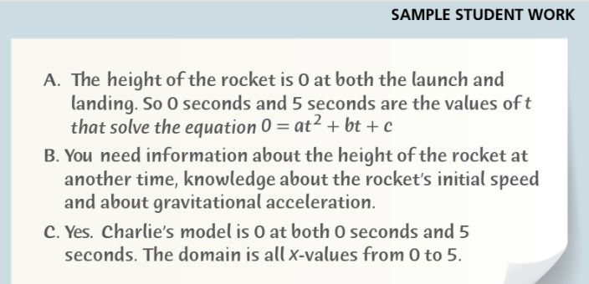Students complete a student-led “Notice and Wonder” on the Savvas Model & Discuss (pg. 149): Charlie and Aiko’s rocket h(t) = at² + bt + c, launching at t = 0, landing at t = 5. They then predict the zeros of f(x) = x(x − 4)(x + 3) from Example 1 (pg. 150). Partners add at least one new noticing to each other’s work. [DOK 2]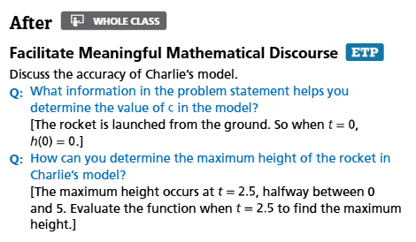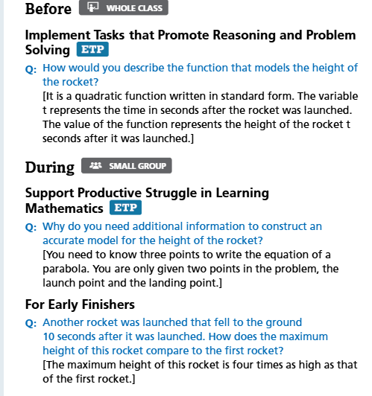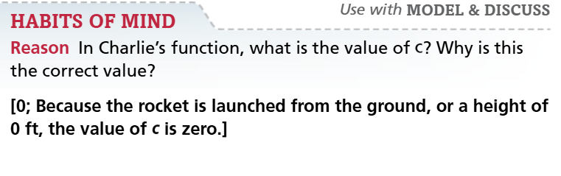
Quick review | Use student ideas to formalize the meaning of a zero: a value of x (or t) that makes the function value 0. Keep teacher talk to a short synthesis after the warm-up.
Investigation | In groups, students use Desmos and blank paper to compare the rocket model and f(x) = x(x − 4)(x + 3). They identify zeros using the Zero Product Property, label intervals above and below the x-axis, and produce a rough sketch supported by test points. [DOK 2–3]
Share / refine | Turn and Talk: “How is a zero shown in an equation, on a graph, and in a real-world context?” Capture one class definition on chart paper using student language first and academic language second.
Exit ticket | Model & Discuss logic: In the rocket model, the zeros are t = 0 and t = 5. Charlie claims he can write the exact equation with only that information. Explain why a third point or initial speed is mathematically required. [DOK 3]
Materials + notes | Materials: laptops, blank paper, pencils, markers, chart paper. Language support: sentence frames for “I notice...”, “I predict...”, and “A zero means...”. Savvas alignment: Model & Discuss (pg. 149) + Example 1 (pg. 150).

Day 2 | Graphing from Factored Form
Use zeros and interval reasoning to sketch the shape of a polynomial graph.

Warm-Up | Students compare Savvas Example 1: f(x) = x(x − 4)(x + 3) with Try It 1a: g(x) = −x(x − 4)(x + 3). They decide what stays the same and what changes, then justify their claims before checking with technology.  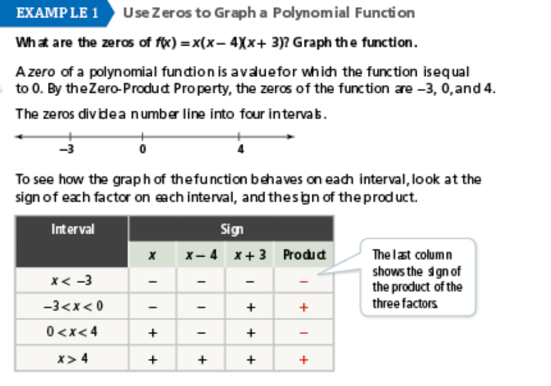  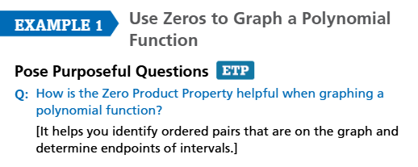[DOK 2]
Quick review | Brief synthesis after the warm-up: zeros come from the factors, while the leading coefficient changes end behavior and vertical stretch.
Investigation | Groups graph Try It 1b: x³ − 9x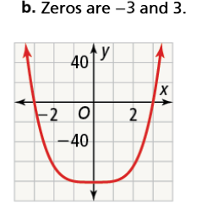 and Practice #12 (pg. 156): f(x) = 3x³ − 9x² − 12x. They plot zeros, test signs in intervals, justify sketches, then work backward from zeros and a y-intercept to determine a leading coefficient. [DOK 1]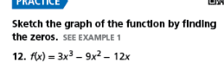 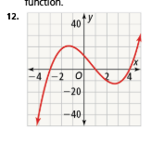
Share / refine | Gallery walk using laptop screens, a shared slide, or chart paper. Students compare sketches and explain where interval testing improved the graph.
Exit ticket | 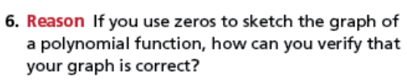  DOK 2
Materials + notes | Materials: laptops plus blank paper. Language support: “The zeros stay the same because...”, “The graph changes because...”. Savvas alignment: Example 1 Try It 1a/1b + Practice #12 & #13, #29 [dok1], #6 [dok2]

Day 3 | Multiplicity
Understand how repeated zeros change graph behavior at the x-axis.

Warm-Up | Students graph Savvas Example 2 (pg. 151): f(x) = (x + 2)²(x − 1) and g(x) = (x + 2)³(x − 1) in Desmos. They compare behavior at x = −2 and predict what the exponent has to do with crossing or touching the x-axis. [DOK 2]  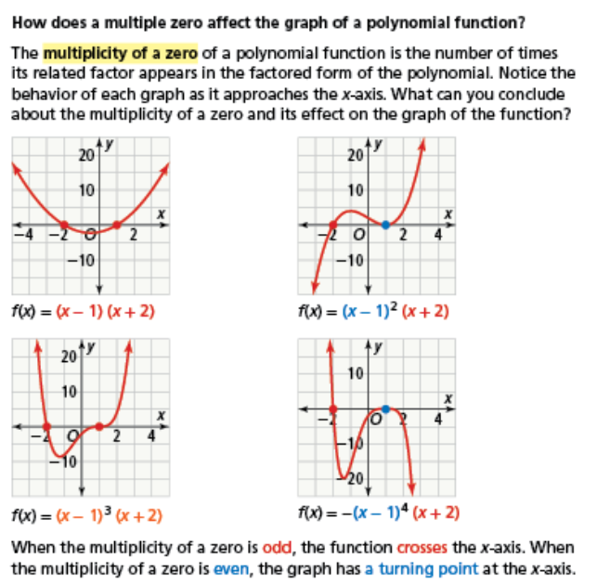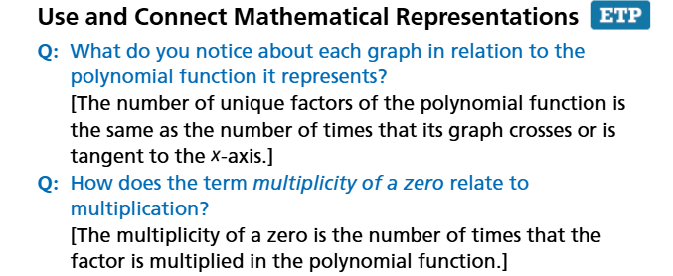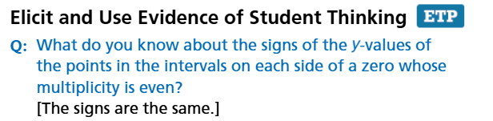  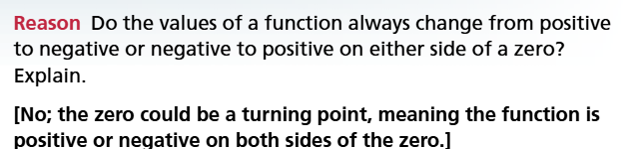  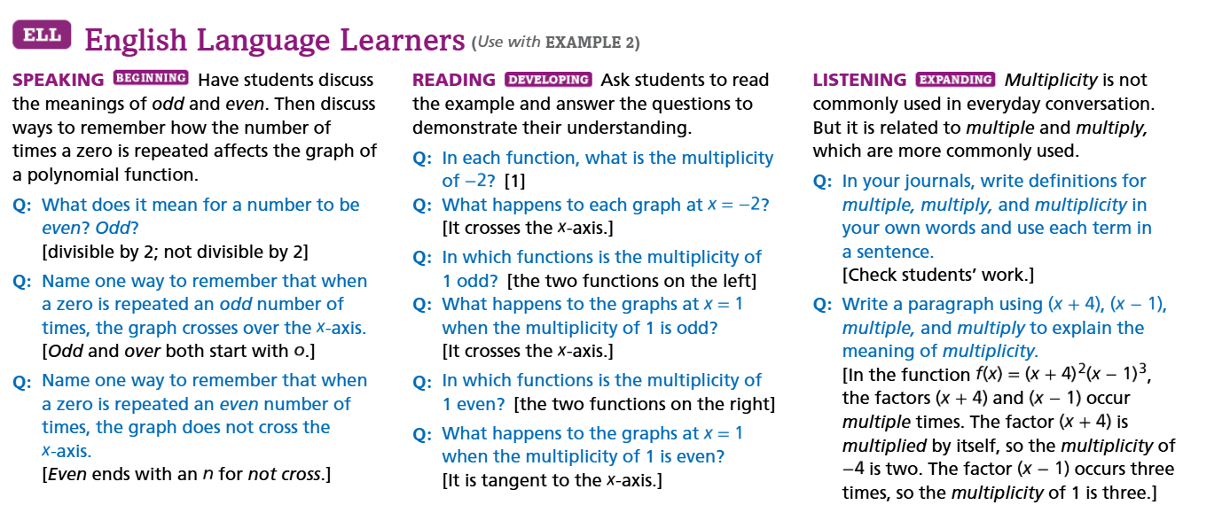
Quick review | Use student observations to formalize even and odd multiplicity. Emphasize crossing versus touching/tangent behavior using student examples.
Investigation | Pairs examine Try It 2b: f(x) = (x² + 9)(x − 1)⁵(x + 2)²  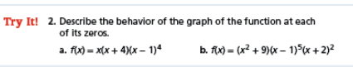  and Practice #15: They determine multiplicity of each zero, test an even/odd rule, then sketch one new function and annotate behavior. [DOK 1]
Share / refine | Quick anchor chart built from student language: “odd multiplicity crosses,” “even multiplicity touches / turns.” Use sentence frames to support explanation.
Exit ticket | 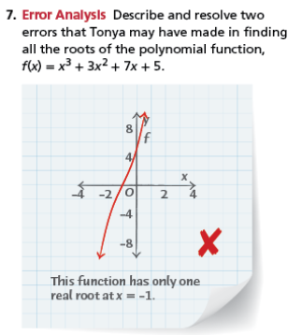 [DOK 2]
Materials + notes | Materials: laptops and blank paper. Language support: even/odd T-chart and speaking frames. Savvas alignment: Example 2 + Try It 2b. Practice #15 +error analysis 7. 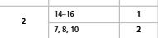

Day 4 | Real and Complex Zeros
Find all zeros of a polynomial when the graph shows only the real zeros.

Warm-Up | Students graph Savvas Example 3 (pg. 152): 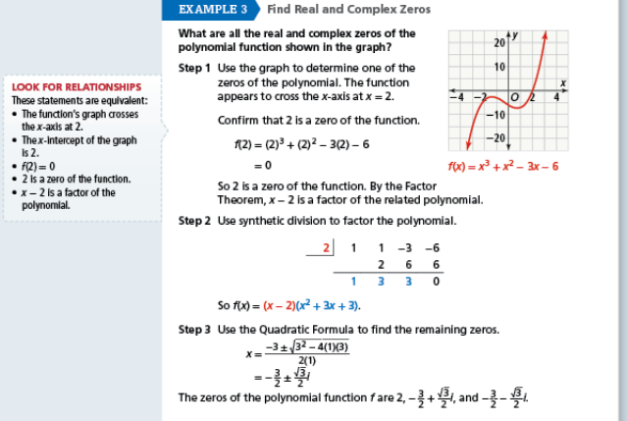f(x) = x³ − 2x² − 2x − 3. The graph shows only one x-intercept at x = 3. They predict the hidden roots. [DOK 2]
Quick review | Synthesize: graphs show real zeros on the x-axis, but a degree-3 polynomial still has three total zeros counting complex roots.  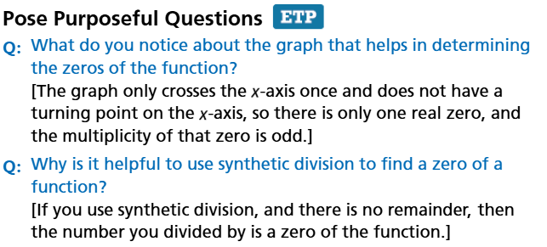
Investigation | Three-step process on Example 3: Graph → Synthetic Division → Quadratic Formula to find x = (−1 ± i√3)/2. Partner practice on Try It 3a: x³ − x² − 5x + 5 = 0. Partner roles: Grapher, Divider, Solver. [DOK 2–3]  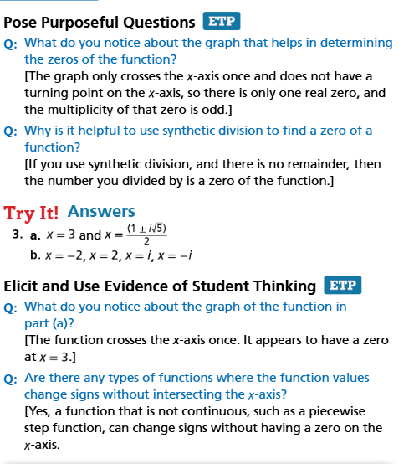
Share / refine | Small groups complete a word-bank summary using real, complex, conjugate, and quotient. They explain why nonreal roots come in conjugate pairs when coefficients are real. [DOK 3]???
Exit ticket | 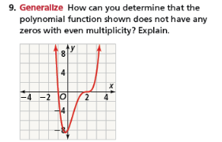[DOK1] 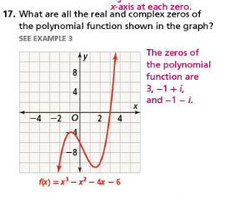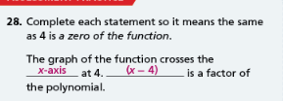
Materials + notes | Materials: laptops, blank paper, chart paper. Language support: word bank and partner roles. Savvas alignment: Example 3 (pg. 152) + Try It 3a.

Day 5 | Real-World Modeling
Interpret zeros, intervals, and domain constraints in a polynomial model.

Warm-Up | Students inspect Savvas Example 4 (pg. 153): Acme Innovations’ profit P(x) = −x³ + 10x² + 11x − 22 with zeros −2, 1, 11. They discuss domain: why don’t partial or negative lamps make sense? [DOK 2]  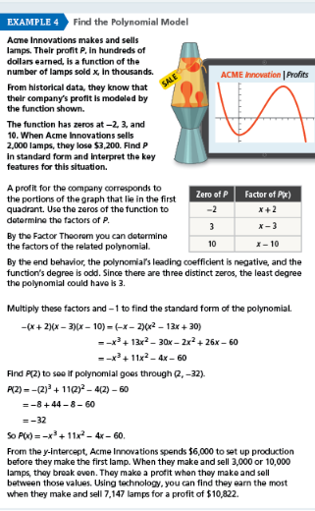
Quick review | 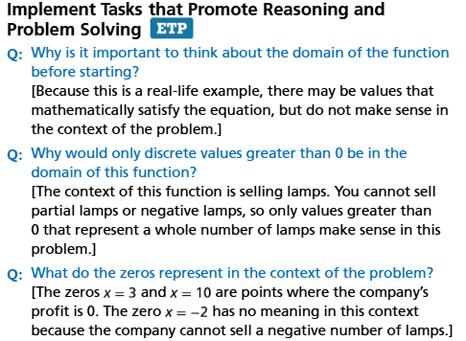  Short synthesis on break-even points, negative profit, and realistic domain.
Investigation | Groups analyze Practice #18 (pg. 156): Waterworks Paddleboards P(x) = −3x³ + 48x² − 144x. They factor, find zeros, interpret positive/negative intervals, and decide which domain values are realistic. [DOK 2]  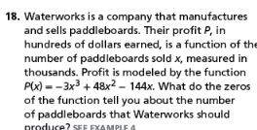
Share / refine | Groups post one claim and one caution about real-world modeling on chart paper. Class compares where math is useful and where the model may break down.
Exit ticket | 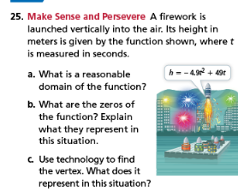 [DOK 3]
Materials + notes | Materials: laptops, blank paper, markers, chart paper. Language support: vocabulary for profit, break-even point, and domain. Savvas alignment: Example 4 (pg. 153) + Practice #18 + Practice #9. 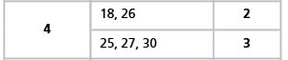

Day 6 | Solving Polynomial Inequalities
Use zeros and sign intervals to decide where a polynomial is positive or negative.

Warm-Up | Students look at Savvas Example 6 (pg. 154): a sketch of f(x) = x³ − 16x. They shade above/below the x-axis and justify each interval with graph evidence. [DOK 2]  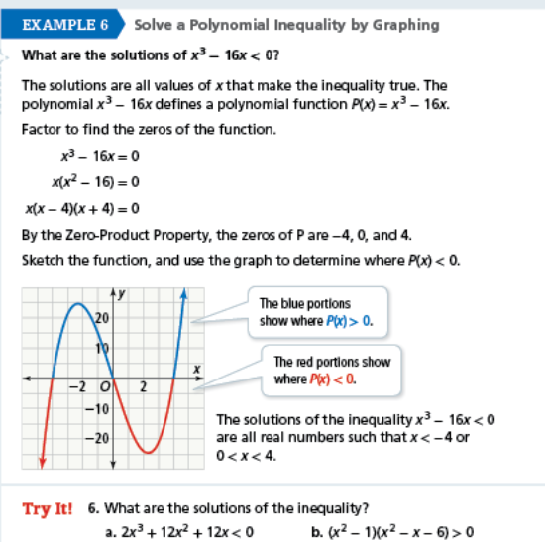
Quick review | Briefly connect above/below the x-axis to inequality symbols; clarify when endpoints are included in interval notation.
Investigation | Students solve Example 6: x³ − 16x < 0 using interval analysis. Partner practice on Try It 6a: 2x³ + 12x² + 12x < 0 and Try It 6b: (x² − 1)(x² − x − 6) > 0. Check answers on Desmos. [DOK 2–3]
Share / refine | Partner explanation round: “Why do we find the zeros first?” “How does the graph help confirm the interval notation?”
Exit ticket | A student solves 2x³ + 12x² + 12x < 0 and writes [−6, −1] ∪ [0, ∞). Evaluate: Is the interval notation correct? Explain parentheses vs. brackets in strict inequalities. [DOK 3]
Materials + notes | Materials: laptops and blank paper. Language support: sentence frame for interval notation. Savvas alignment: Example 6 (pg. 154) + Try It 6a & 6b.  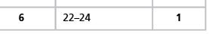

Day 7 | Synthesis, Review, and Critique
Communicate mathematical reasoning across equations, graphs, multiplicity, and inequalities.

Warm-Up | Savvas Practice #29 (pg. 157) SAT/ACT practice: Match the correct graph to f(x) = x³ + x² − 4x using end behavior and zeros. Explain your elimination strategy.  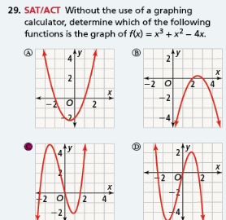 [DOK 2–3]
Quick review | Debrief selected graph-matching strategies and tighten language. Emphasize precision rather than re-teaching.
Investigation | Jigsaw groups work on Savvas Performance Task #30 (pg. 157): Venetta’s Deli P(t) = t³ + t² − 6t. Part A: Sketch. Part B: Non-profit years. Part C: Predict 2020 profit. Each group also prepares one conceptual explanation. [DOK 3]  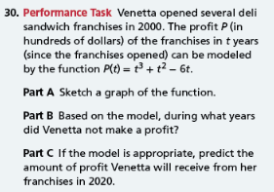
Share / refine | Students critique another group’s explanation by asking a question, offering a counterexample, or strengthening the evidence.
Exit ticket | Critique the real-world limitations of Venetta’s profit model. Is it realistic to assume a cubic function will perfectly model business profit forever? [DOK 3]
Materials + notes | Materials: laptops, blank paper, markers, chart paper. Language support: discussion stems for critique. Savvas alignment: Practice #29 (SAT/ACT) + Practice #30 (Performance Task).

Day 8 | Assessment and Differentiated Stations
Assess mastery and target support without returning to a teacher-centered lesson.

Warm-Up | 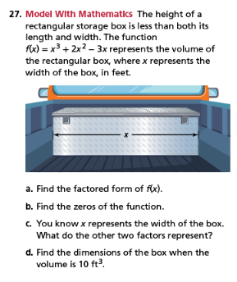
Quick review | Three-minute strategy reset: choose a representation first (factored form, graph, sign chart, or synthetic division) instead of rushing into procedure.
Investigation | Students complete the Savvas Lesson Quiz (pg. 157): 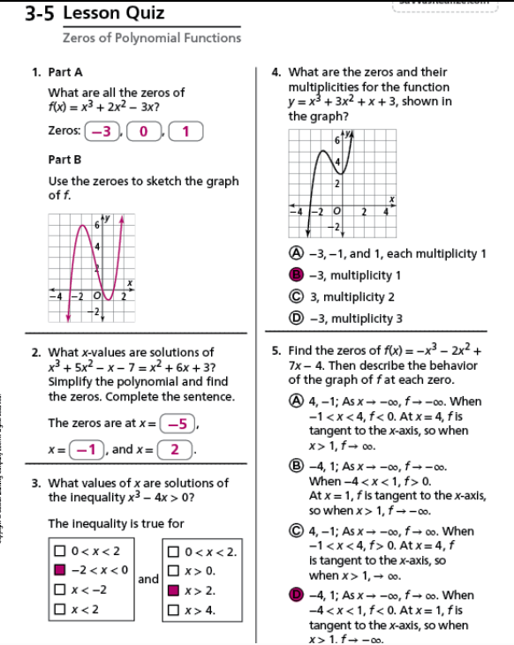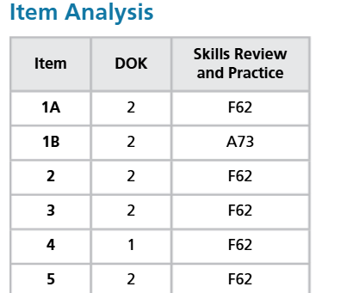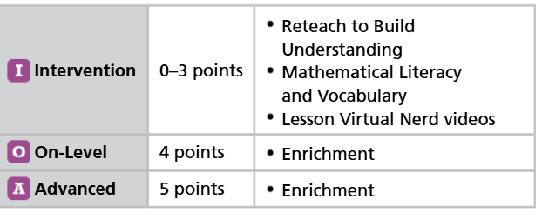
Share / refine | Students compare which representation helped them most on the mastery check and why.
Exit ticket | Reflect on your learning. Which representation do you find most helpful: Factoring/Algebra, Desmos/Visual Graphing, or Synthetic Division?
Materials + notes | Materials: laptops, blank paper, chart paper, markers. Teacher move: conference with targeted students while others work independently. Savvas alignment: Practice #7 + Lesson Quiz (pg. 157) + Differentiated Resources (Reteach, Vocab, Enrichment).

Day 1 Student Page | What is a zero?
Complete on your laptop, in a notes app, or on blank paper. Record your final thinking here.

Notice & Wonder | Model & Discuss (pg. 150b)  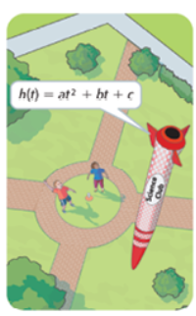  Prompt A: Charlie and Aiko launched a model rocket. It launched from the ground at t = 0 seconds and landed at t = 5 seconds. Charlie claims the equation is exactly h(t) = at² + bt + c.  • What do you notice about the launch and landing times?  • What do you wonder about the missing letters a, b, c?  Prompt B: Look at the function f(x) = x(x − 4)(x + 3). Predict the x-intercepts using the Zero Product Property.

Explore | Savvas Example 1 (pg. 150)  - Use Desmos to graph f(x) = x(x − 4)(x + 3).  - Record the exact zeros of the function.  - Explain what a zero represents in the rocket situation vs. the pure math equation.  - Sketch f(x) and pick one “test point” in each interval to prove if the graph is above/below the x-axis.
Discuss | How is a zero represented in an equation, on a graph, and in a context? Use both functions in your explanation.
CER (Exit Ticket) | In Charlie and Aiko’s rocket model, the zeros are t = 0 and t = 5. Charlie claims he can write the exact equation of the parabola with only that information. Do you agree or disagree? Explain why additional information (like a third point or initial speed) is mathematically required.  Claim:  Evidence:  Reasoning:

Day 2 Student Page | Graphing from Factored Form
Use blank paper for sketches and Desmos for quick checks. Explain every graph using zeros and intervals.

Compare | Savvas Example 1  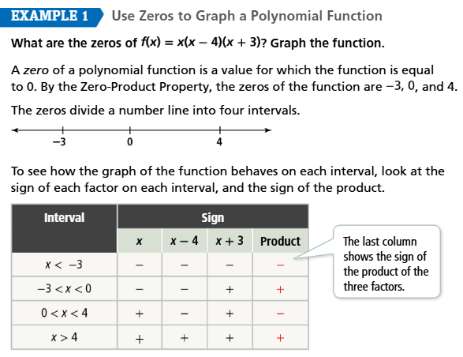  Compare f(x) = x(x − 4)(x + 3) and g(x) = −x(x − 4)(x + 3).  • What will stay the exact same when graphed?  Z  • What will change? How do you know before graphing?

Build the graph | Savvas Practice #12 & #13 (pg. 156)  - Use Desmos to check your warm-up prediction.  - On blank paper, sketch f(x) = 3x³ − 9x² − 12x. (Hint: factor out the GCF first!)  - Sketch g(x) = x³ − 8x² + 16x. (Practice #13)  For each function, list the zeros, choose a test point in each interval, and justify the rough shape.

Explain | Which is more useful when sketching: the zeros or the test points? Defend your answer with at least one example from today.

CER (Exit Ticket) | Reason: If you use zeros to sketch the graph of a polynomial function, how can you verify that your graph is correct? (Savvas Practice #6)  Claim: __________  Evidence: __________  Reasoning: __________

Day 3 Student Page | Multiplicity
Use Desmos to compare graphs and use words like cross, touch, turn, even, odd, and multiplicity.

Graph and compare | Savvas Example 2 (pg. 151)  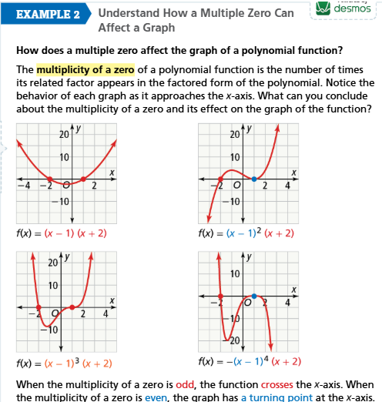  Graph y = (x + 2)²(x − 1) and y = (x + 2)³(x − 1) on Desmos.  • What happens at the zero x = −2 in the first graph?  • What happens at x = −2 in the second graph?  • What do you predict the exponent (multiplicity) has to do with the behavior?

Create a rule | Savvas Try It 2b & Practice #15  1. For each function below, identify the zero(s), multiplicity, and graph behavior (Crosses or Touches):  a. f(x) = (x² + 9)(x − 1)⁵(x + 2)²  b. g(x) = x³ − x² − 25x + 25 (Hint: factor by grouping!)  2. Write a rule in words: When multiplicity is odd… When multiplicity is even…  3. Test your rule by sketching one new function from your group.

Sentence frames | When the multiplicity is odd, the graph __________ the x-axis.  When the multiplicity is even, the graph __________ at the x-axis.

CER (Exit Ticket) | Savvas Practice #7 — Error Analysis (pg. 156)  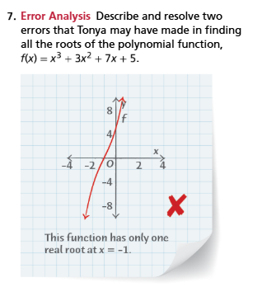  (Hint: Check end behavior AND the number of turning points for a cubic.)  Claim: _________  Evidence: __________  Reasoning: _________

Day 4 Student Page | Real and Complex Zeros
Finding ALL zeros of a polynomial using graphing, synthetic division, and the quadratic formula.

Notice & predict | Savvas Example 3 (pg. 152)  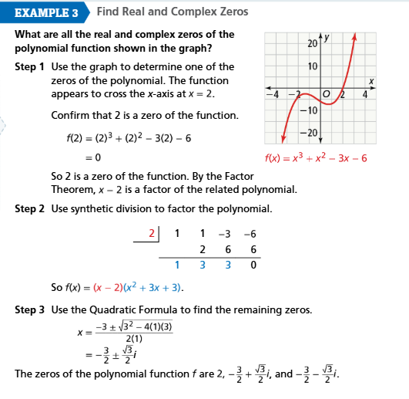  Graph f(x) = x³ − 2x² − 2x − 3.  • The graph shows only one x-intercept. What is it  • Because it’s a cubic (degree 3), what do you predict about the other two roots?
Three-step process |  | Step 1: Graph the polynomial to find the real zero.  Step 2: Use Synthetic Division by that real zero to create a smaller quotient.  Step 3: Use the Quadratic Formula x = (−b ± √(b² − 4ac)) / (2a) on the quotient to find the remaining complex zeros.

Guided example | Find all zeros of f(x) = x³ − 2x² − 2x − 3.  - Graph it: Real zero at x = ______  - Synthetic Division: Divide by the real zero. The reduced quotient is x² + ____x + ____.  - Quadratic Formula: Solve x² + x + 1 = 0.  Final zeros: ______________________
Think-Pair-Share | Savvas Try It 3a  Find all the zeros of g(x) = x³ − x² − 5x + 5.  (Hint: You can use the graph + synthetic division process, OR try factoring by grouping!)  Student A: find the real zero and set up synthetic division.  Student B: finish the division and set up the Quadratic Formula.  Together: solve for the final roots.  Language check: Use these words in your explanation — real, complex, conjugate, quotient.

CER (Exit Ticket) | 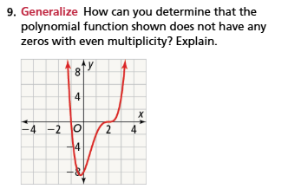  Claim: __________  Evidence: __________  Reasoning: __________

Day 5 Student Page | Real-Worldodeling
Interpret zeros and sign intervals in context. Use the graph and the equation together.

Think about the context | Savvas Example 4 (pg. 153)  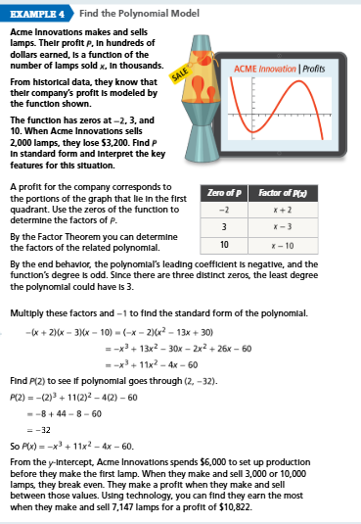  • Which zero does not make sense in the context of this problem? Why?  • Between what production amounts does Acme make a positive profit?

Waterworks Paddleboards | Savvas Practice #18 (pg. 156)  Waterworks profit P(x) (in hundreds of dollars) based on x paddleboards sold (in thousands) is modeled by: P(x) = −3x³ + 48x² − 144x.  - Factor to find the zeros.  - What are the solutions to the equation P(x) = 0?  - When P(x) is positive, the company earns a profit. Over what interval(s) does the company make a profit?

Discuss domain | Why must we think about domain in a business problem, even when the algebra allows many more x-values?

CER (Exit Ticket) | Savvas Practice #25 — Make Sense and Persevere  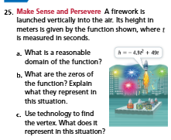  A.  Claim: __________  Evidence: __________  Reasoning: __________  B.  Claim: __________  Evidence: __________  Reasoning: __________  C.  Claim: __________  Evidence: __________  Reasoning: __________

Day 6 Student Page | Solving Polynomial Inequalities
Use zeros and graphs to find where a function is positive or negative.

Visualizing inequalities | Savvas Example 6 (pg. 154)  Look at the graph of f(x) = x³ − 16x.  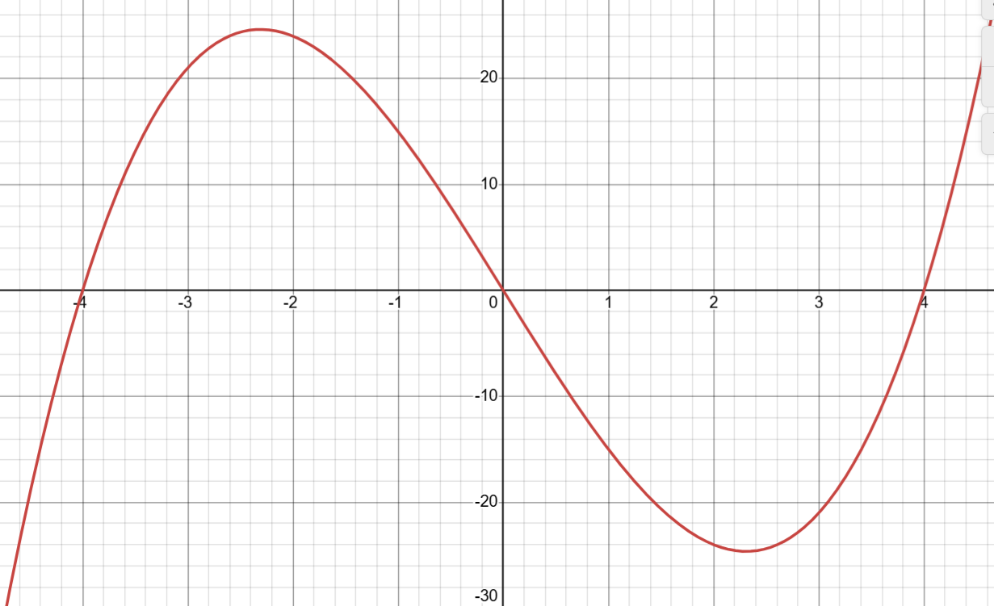  • If f(x) < 0, we are looking for where the graph is BELOW the x-axis  • Color-code or highlight the exact intervals on the graph where this happens.

Guided example | Solve the inequality x³ − 16x < 0 algebraically.  - Find the zeros by factoring x(x² − 16) < 0. Zeros are 0, −4, 4.  - Plot the zeros on a number line and test the intervals: (−∞, −4), (−4, 0), (0, 4), (4, ∞).  3. Write the final solution in interval notation.

Partner practice | Savvas Try It 6a & 6b  - Solve: 2x³ + 12x² + 12x < 0  - Solve: (x² − 1)(x² − x − 6) > 0  Use blank paper for your number line and sign testing. Check your answers by graphing on Desmos.

Explanation frame | The solution includes the intervals __________ and __________ because the graph is __________ the x-axis in those regions. We use brackets instead of parentheses because the inequality is __________.

CER (Exit Ticket) | A student solves 2x³ + 12x² + 12x > 0 and writes the answer as [−6, −1] ∪ [0, ∞). Evaluate their answer. Is their interval notation correct? Explain the difference between using parentheses ( ) and brackets [ ] in inequalities.  Claim: __________  Evidence: __________  Reasoning: __________

Day 7 Student Page | Synthesis and Critique
Use this page to argue, critique, and connect the big ideas from the whole unit.

SAT/ACT Practice | Savvas Practice #29 (pg. 157)  Without using a graphing calculator, determine which of the 4 graphs provided represents f(x) = x³ + x² − 4x.  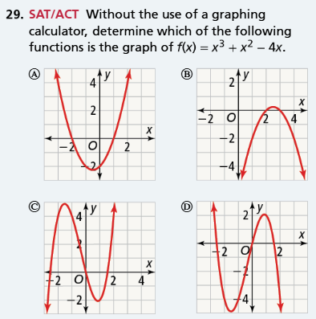  Explain to your group how end-behavior and factoring helped you eliminate the wrong choices.

Performance Task | Savvas Practice #30: Venetta’s Deli (pg. 157)  Venetta opened several deli sandwich franchises in the year 2000. Her profit P(t), in hundreds of dollars, after t years can be modeled by P(t) = t³ + t² − 6t.  Part A: Sketch a graph of the function.  Part B: Based on the model, during what years did Venetta NOT make a profit?  Part C: If the model is appropriate, predict the amount of profit Venetta will receive from her franchises in the year 2020.

Listen and respond | Listen to another group’s explanation. Add one question, one counterexample, or one way to strengthen the evidence.

CER (Exit Ticket) | Critique the Model  Based on your answer to Part C of the Venetta problem, you predicted a specific profit for the year 2020. Critique the limits of this mathematical model. Is it realistic to assume a cubic function will perfectly model business profit forever? Why or why not?  Claim: __________  Evidence: __________  Reasoning: __________

Day 8 Student Page | Mastery Check and Reflection
Use the assessment to show what you can do, then choose the station that best helps you keep growing.

Error analysis | Savvas Practice #27 (pg. 157)  The height of a rectangular storage box is less than both its length and width. The function f(x) = x³ + 2x² − 3x represents the volume, where x is the width in feet.  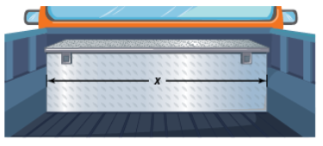  (a) Find the factored form.  (b) Find the zeros.  (c) What do the other two factors represent?  (d) Find dimensions when volume is 10 ft³.

Mastery Check | Savvas Lesson Quiz (pg. 157)  Do your best on these 3 problems without graphing technology.  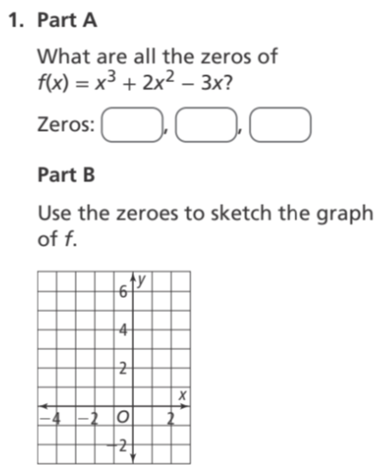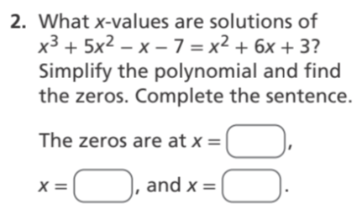  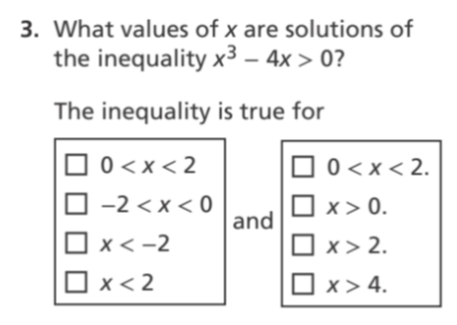

Choose a Station | Savvas Differentiated Resources  Station 1 (Reteach): Work with the teacher on “Reteach to Build Understanding” (focus on factoring and sign charts).  Station 2 (Mathematical Literacy): Work on the Vocabulary worksheet matching graphs to roots, multiplicities, and terms.  Station 3 (Enrichment): Complete the advanced problem-solving task predicting higher-degree polynomial behaviors.

CER (Exit Ticket) | Reflect on your learning. When trying to graph or solve a polynomial, which representation do you find most helpful and why: Factoring/Algebra, Desmos/Visual Graphing, or Synthetic Division?  Claim: __________  Evidence: __________  Reasoning: __________

